Aishwarya Ledalla

Design Optimization HW 2

9/15/2021

**Problem 1**

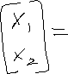

The stationary point is at

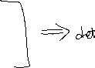

Indefinite

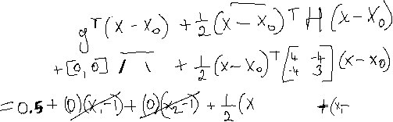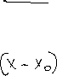

This inequality defines both downslopes

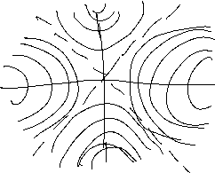

**Problem 2**

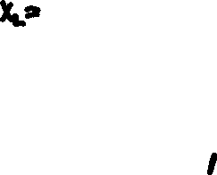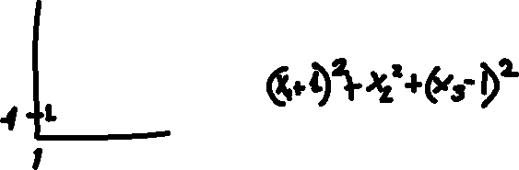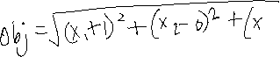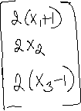

**Problem 3**

**Given $f\left(x\right)\text{and }g\left(x\right)$ are two convex functions defined on the convex set X**

1. **Prove that $af\left(x\right)+bg\left(x\right)$ is a convex set for**

Let , and

Since are convex sets,

For every point in , there is a corresponding point in , when they are added together, there is an overall function that is convex as well. For example:

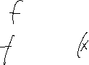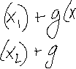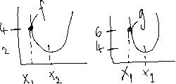

The convex inequality will hold true because the function of the sum of follows the same pattern as both functions

1. **In what conditions will be convex**

Ifis convex, then is convex. And the nature of is similar to .

It follows the pattern of both but gives a function with larger values compared to .

**Problem 4**

**Show $f\left(x_{1}\right)≥f\left(x_{0}\right)+{g_{x_{0}}}^{T}\left(x_{1}-x_{0}\right)$ for a convex function $f\left(x\right):X→R$ and for $x_{0},x_{1}∈X$**

**Problem 5**

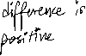

1. **Formulate this problem as an optimization problem.**
2. **Is your problem convex?**

Taking the gradient of the general objective function:

Taking the Hessian of the general objective function:

According to Lemma: if then H is p.s.d.

The H is p.s.d when d is orthogonal to because then would be zero.

The problem is not convex because H is either p.s.d or indefinite.

1. **If we require the overall power output of any of the n lamps to be less than $p^{*}$, will the problem have a unique solution?**

If the function is convex, then the solution will inherently be unique. If the overall power out of the lamps in less than , which is a constant across all planes making it a constant in ’s

space. Since it is a constant everywhere, is a convex function. And is a convex function too as it spans m number of dimensions. An intersection of 2 convex spaces is a convex function itself.

1. **If we require no more than half of the lamps to be switched on, will the problem have a unique solution?**

If there are only n/2 lamps that are switches on, there can be multiple combinations of lamps which can give an equivalent optimal power output. For example, given there are n=2 number of lamps that are switched on, the situation where 1 one of them being switched on would give the same solution as the other being switched on. This is because of the symmetry of the set-up and equivalent reflection intensity of the lamps. So, there are no unique solutions, but multiple optimal solutions.